SWT 22022 – Practical for Internet Application Development
Department of Information and Communication Technology
Faculty of Technology
Lab sheet :02
Reg. Number: SEU/IS/20/ICT/084
Academic Year :2020/2021
Date: 2024.06.12
Practical No :02

Title:
- Introduction to PHP - II.
Aims:
• Refresh the knowledge on operators.
• Refresh the knowledge on PHP statements.
• Refresh the knowledge on PHP Loops.
• Introduction to PHP functions and arrays
Tasks:
• Operators in PHP
• PHP Conditional Statements
• PHP Loops
• PHP Functions
• PHP Arrays
Activities
1. Operators in PHP
I. Try each operator and display its outputs
CODE
<?php

echo "------------------------------------------------------------------------- <br>";
echo" Arithmetic Operators + , - , * , / , % , ++ , ";
echo"<br>";
echo "------------------------------------------------------------------------- <br>";
echo"<br>";
$number1 = 45;
$number2 = 67;
$sum = $number1 + $number2;
echo "Sum : " . $sum;
echo"<br>";

echo"<br>";
echo "------------------------------------------------------------------------- <br>";
echo "Comparison Operators == , != , > , < , >= , <= ";
echo"<br>";
echo "------------------------------------------------------------------------- <br>";
echo"<br>";
$number3 = 45;
$number4 = 67;
$is_equal = $number1 == $number2;
echo "Is Equal ( ".$number3.",".$number4." ) : " . $is_equal;
echo"<br>";

echo"<br>";
echo "------------------------------------------------------------------------- <br>";
echo " Logical Operators and , or , && , || , !";
echo"<br>";
echo "------------------------------------------------------------------------- <br>";
$true_val = true;
$false_val = false;
$and_operator = ($true_val and $false_val);
echo "AND ( " . $true_val . "," . $false_val . " ) : " .$and_operator;
echo"<br>";

echo"<br>";
echo "------------------------------------------------------------------------- <br>";
echo " Assignment Operators = , += , -= , *= , /= , %= ";
echo"<br>";
echo "------------------------------------------------------------------------- <br>";
echo"<br>";
$var1 = 23;
$var2 = 34;
$assignment_opr = $var1 + $var2;
echo "Simple Assignment ( " . $var1 . "," . $var2 . " ) : " . $assignment_opr;
echo "<br>";

echo"<br>";
echo "------------------------------------------------------------------------- <br>";
echo "String Operators . , .=";
echo"<br>";
echo "------------------------------------------------------------------------- <br>";
echo"<br>";
$string_var1 = "Olivia";
$String_var2 = "Edith";
$string_var1 .= $String_var2;
echo $string_var1;
echo "<br>";

echo"<br>";
echo "------------------------------------------------------------------------- <br>";
echo "Conditional Operators ?";
echo"<br>";
echo "------------------------------------------------------------------------- <br>";
echo"<br>";
$number5 = 3;
$number6 = 4;
$cond_output = $number5 == $number6 ? "Number_5 and Number_6 areequal." : "Number_5 and Number_6 are not equal.";
echo $cond_output;

?>
Output:
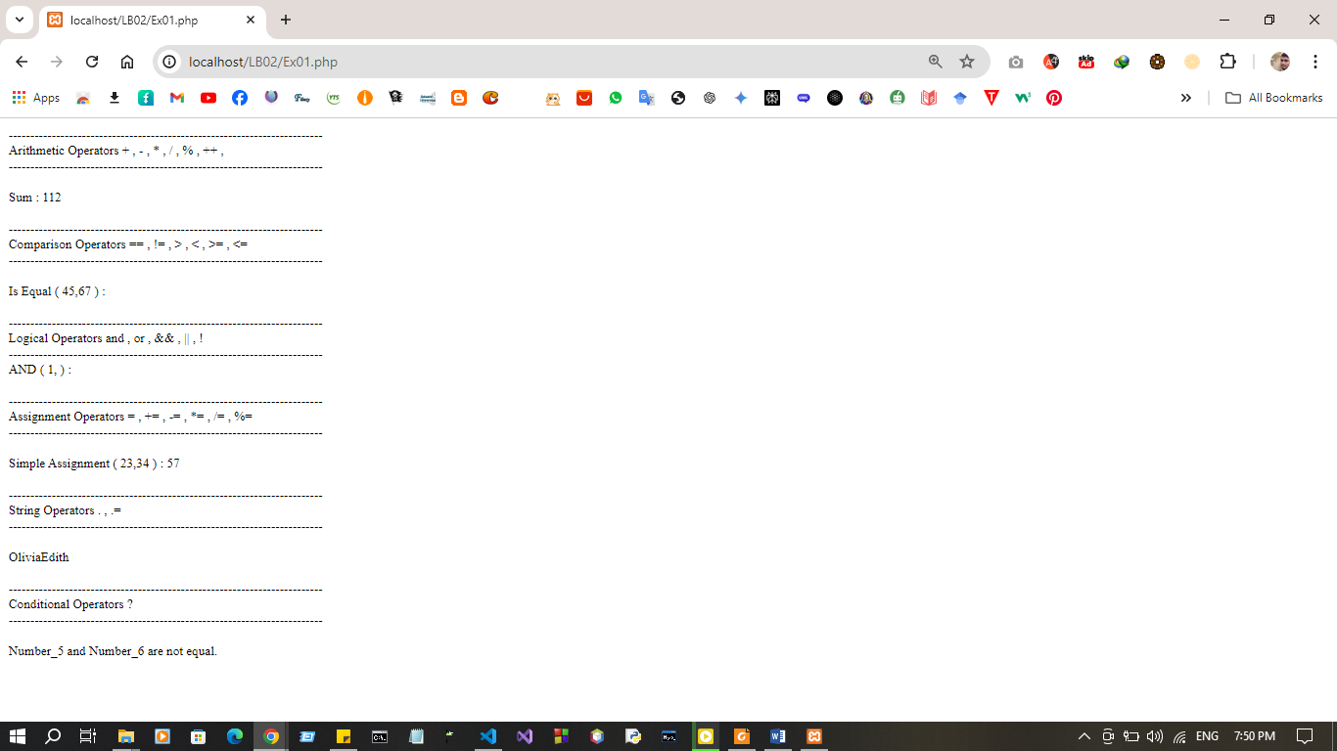
2. Conditional Statements of PHP
<?php
// IF STATEMENT
if (condition) {
// code to be executed if condition is true;
}
// IF-ELSE STATEMENT
if (condition) {
// code to be executed if condition is true;
} else {
// code to be executed if condition is false;
}
// IF-ELSEIF-ELSE STATEMENT
if (condition) {
// code to be executed if this condition is true;
} elseif (condition) {
// code to be executed if first condition is false and this
condition is true;
} else {
// code to be executed if all conditions are false;
}
?>
I. If the room temperature is above 72 degrees Fahrenheit, turn on the air conditioner. If the temperature is below 68 degrees Fahrenheit, turn on the heater. Else, maintain the current temperature.
CODE :
<?php

$room_temperature = 66;

if ($room_temperature >= 72) {
echo "Turning on the air conditioner.\n";;
} elseif ($room_temperature <= 68) {
echo "Turning on the heater.\n";
} else {
echo "Maintaining current temperature.\n";
}
?>
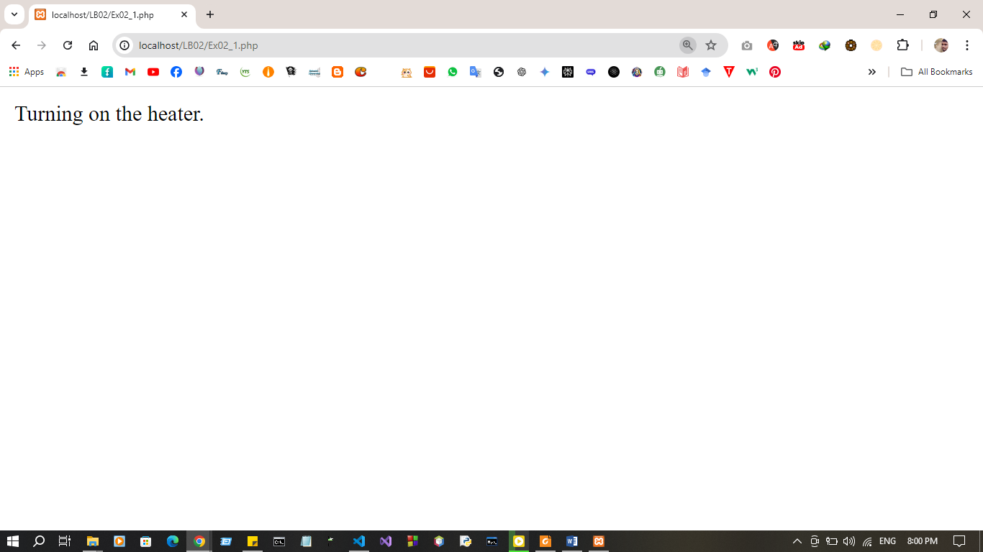
Output:

<?php
// SWITCH STATEMENT
switch (expression) {
case label1:
//code block
break;
case label2:
//code block;
break;
case label3:
//code block
break;
default:
//code block
}
?>

II. Imagine a vending machine that dispenses different snacks based on user selection. The user presses a button corresponding to a specific snack code:
C001 : for Chips
C002 : for Cookies
C003 : for Candy Bar
D : Invalid selection

CODE :
<?php

$user_selection = 'C002';
switch ($user_selection) {
case 'C001':
echo "Dispensing Chips.\n";
break;
case 'C002':
echo "Dispensing Cookies.\n";
break;
case 'C003':
echo "Dispensing Candy Bar.\n";
break;
default:
echo "Invalid selection.\n";
break;
}

?>
Output :
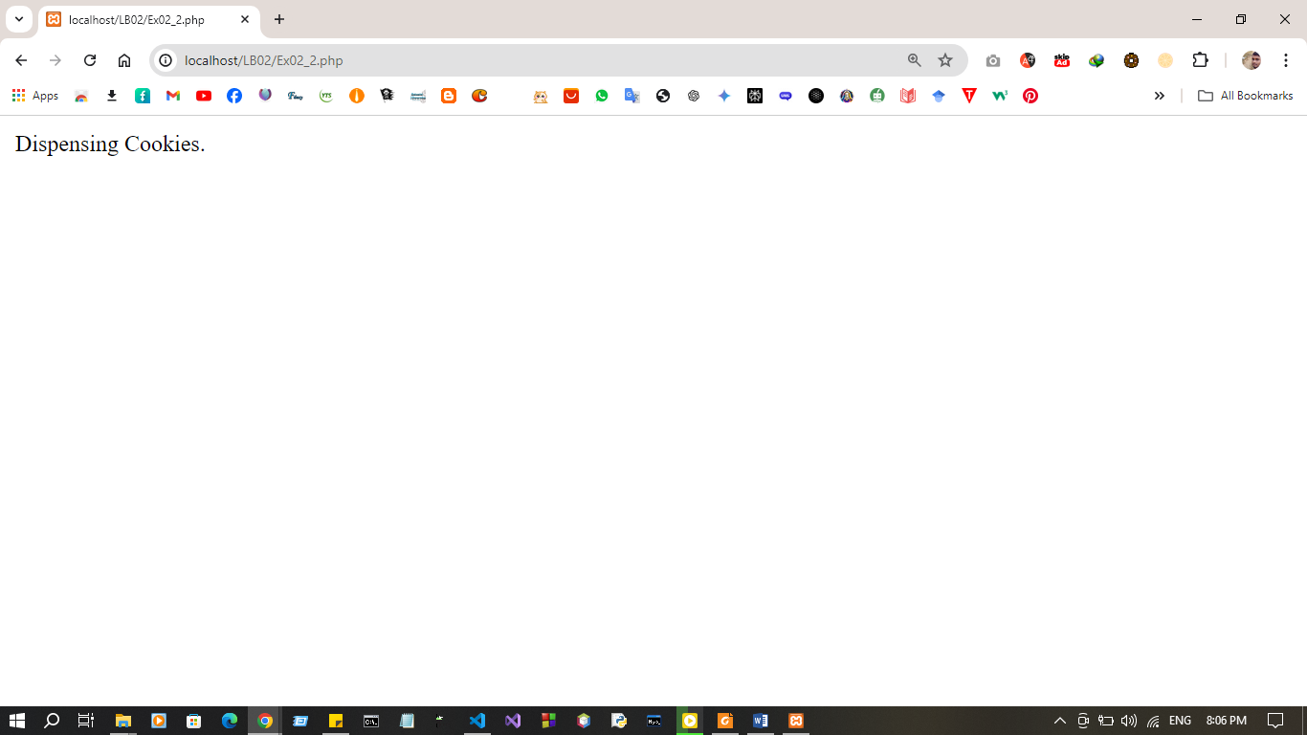
3. Loops of PHP
<?php
//while loop
while (condition) {
# code...
}
//do.. while loop
do {
# code...
} while (condition);
?>

I. Create a script that displays 1-2-3-4-5-6-7-8-9-10 on one line. There will be no hyphen(-) at starting and ending position

CODE:

<?php

$x=0;
while ($x<=10) {
echo "$x"." ";
$x++;

}

?>

Output:

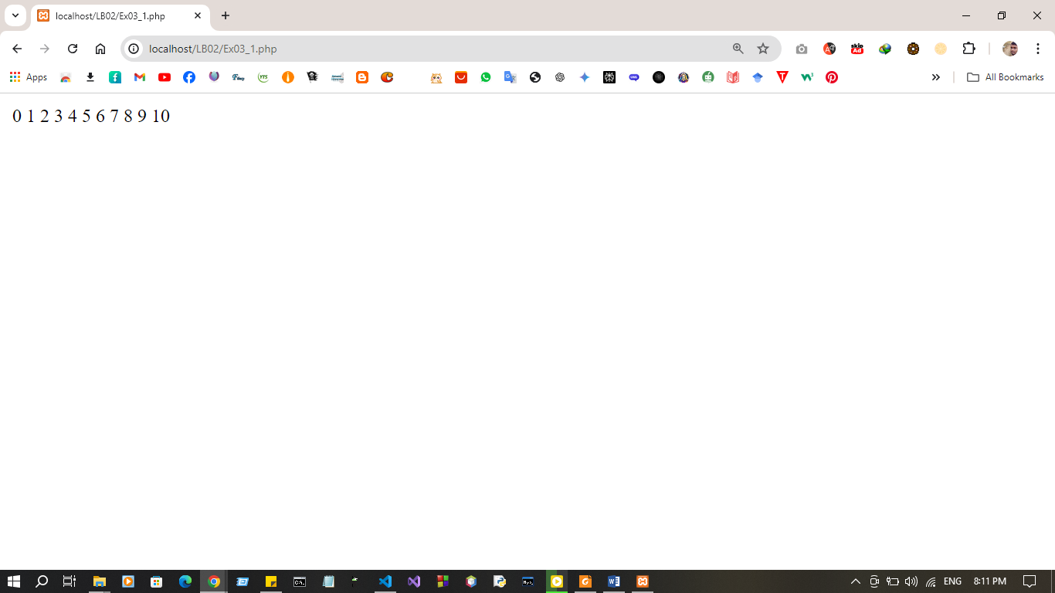

<?php
//for loop
for (expression1, expression2, expression3) {
// code block
}
?>

II. Write a for loop that generates a multiplication table for a number 7. The loop should iterate from 1 to 10 and print each number multiplied by 7.

CODE:

<?php

for ($i = 1; $i <= 10; $i++) {
$result = 7 * $i;
echo "7 x $i = $result <br>";
}
?>

Output:
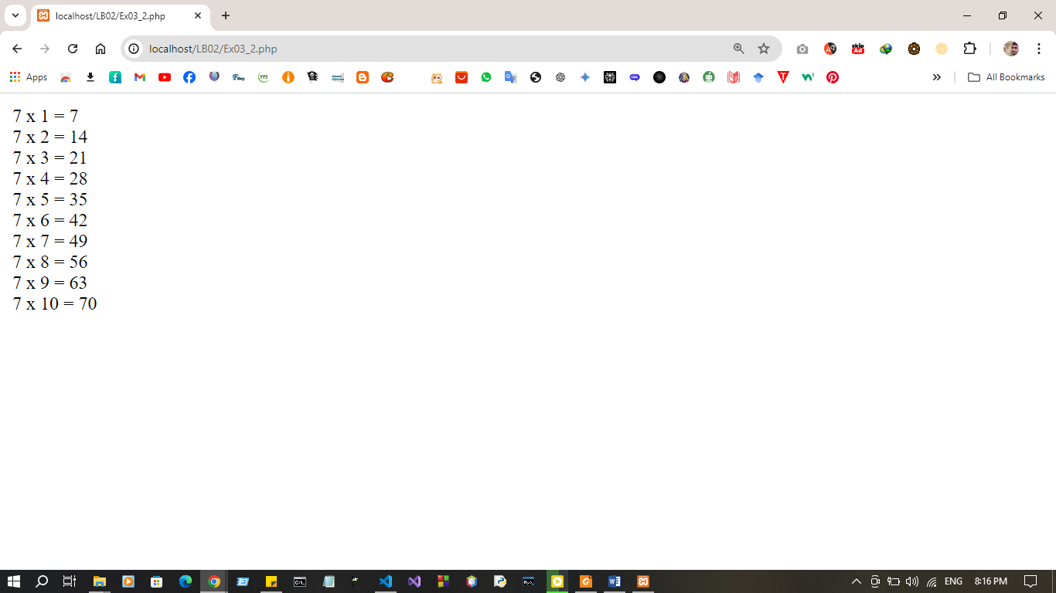

<?php
//foreach loop
foreach ($array_var as $value) {
# code...
}
?>

III. Imagine you have an array containing items in a shopping cart (e.g., ["apples", "bread", "milk"]). Write a foreach loop that iterates through this array and prints the name of each item in the cart.

Code:
<?php
$shopping_cart = ["apples", "bread", "milk"];
foreach ($shopping_cart as $item) {
echo $item . "<br>";
}
?>

Output:
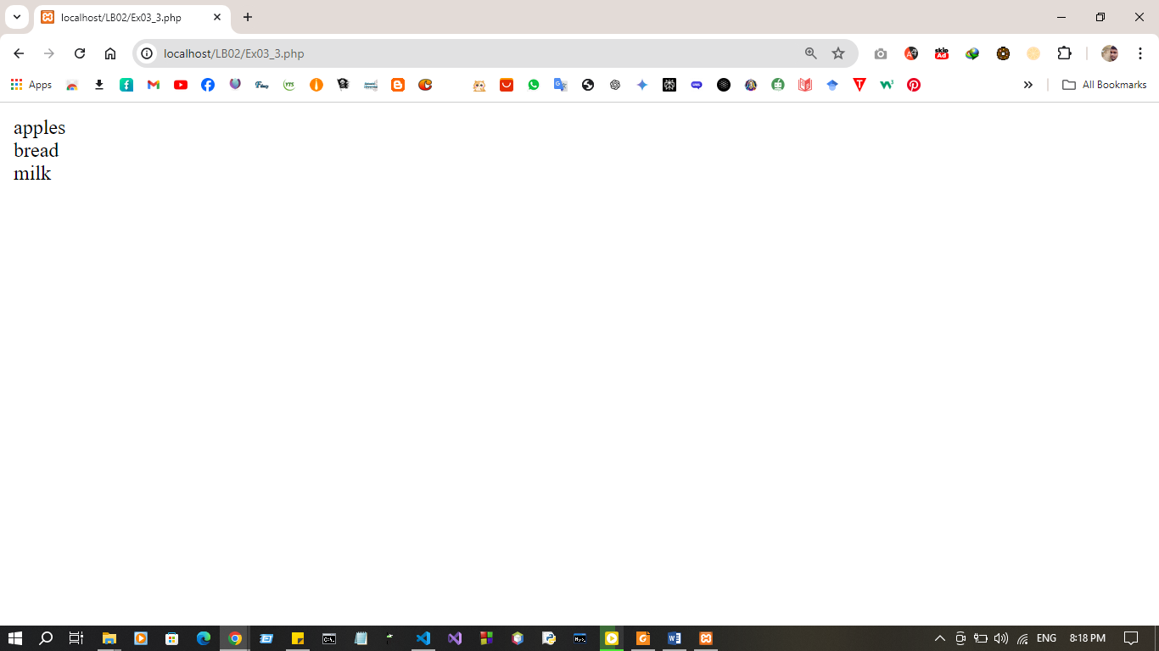

4. Functions of PHP
<?php
function function_name (arguments) {
# code...
}
function_name(value);
?>

I. Imagine you're writing a program to calculate the total bill amount for customer’s purchase. Here's how you can achieve that using functions:
- Function to calculate the tax amount( calculate_tax_amount ): This function takes two parameters: price and tax_rate . It calculates the tax amount by multiplying the price by the tax rate and returns the result.
- Function to calculate the total bill: This function takes two parameters: price and tax_rate. It calls the calculate_tax_amount function (defined earlier) to get the tax amount for the given price and tax rate. Then, it adds the tax amount to the original price to get the total bill amount and returns the final amount.
- Calling the functions and displaying the outputs.

Code:
<?php

function calculate_tax_amount($price, $tax_rate) {
$tax_amount = $price * $tax_rate;
return $tax_amount;
}

function calculate_total_bill($price, $tax_rate) {
$tax_amount = calculate_tax_amount($price, $tax_rate);
$total_amount = $price + $tax_amount;
return $total_amount;
}

$price = 100;
$tax_rate = 0.08;

$tax_amount = calculate_tax_amount($price, $tax_rate);
$total_amount = calculate_total_bill($price, $tax_rate);

echo "Price: $$price <br>";
echo "Tax Amount: $$tax_amount <br>";
echo "Total Bill Amount: $$total_amount <br>";
?>

Output:
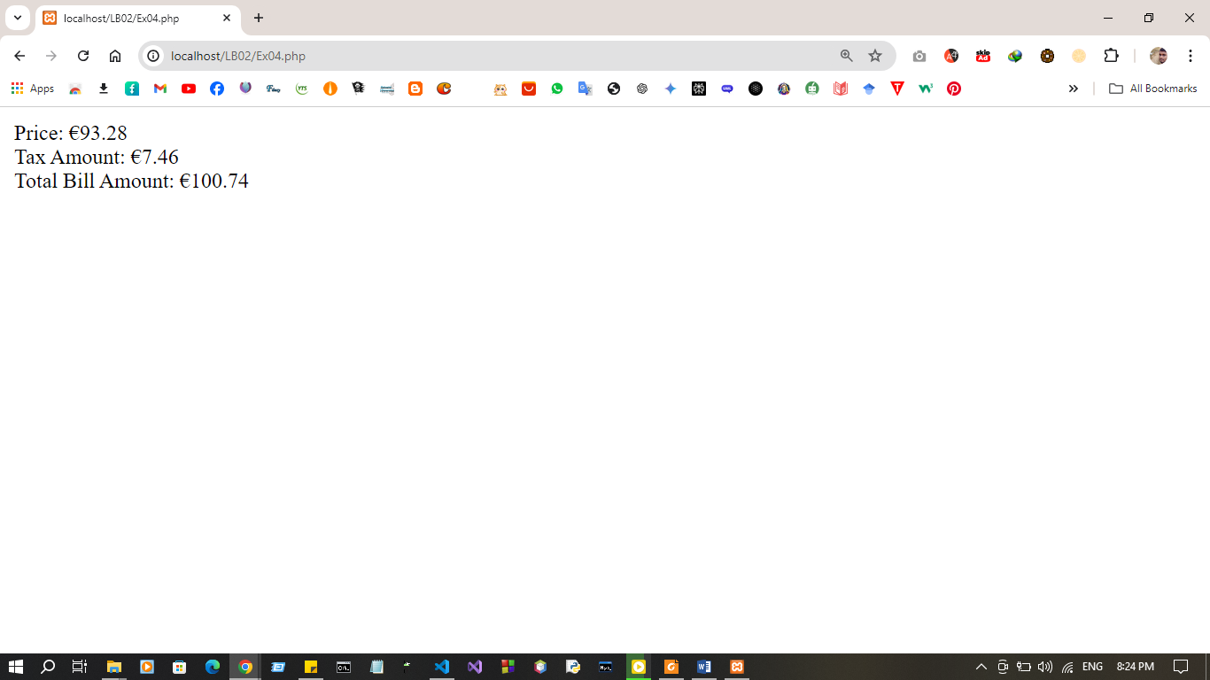

5. Arrays of PHP

<?php
// To define - can use array() construct or [] syntax
$empty_array1 = array();
$empty_array2 = [];
$numbers1 = array(1, 2, 3);
$numbers2 = [1, 2, 3];
?>

I. Imagine you're managing a shopping cart system where items are stored in an array. Each item is represented as an associative array with properties like "name", "price", and "quantity". You want to implement functions to achieve the

following:
- Calculate total per item: This function should take a single item (associative array) as input and calculate the total cost for that specific item by multiplying the "price" by the "quantity". It should return the calculated total cost.
- Calculate total bill: This function should iterate through the entire shopping cart array containing all items. Within the loop, it should call the previously defined function (calculate total per item) for each item in the cart. It should accumulate the individual item totals and return the final total bill amount

Code :
<?php
function calculate_total_per_item($item) {
$total_cost = $item['price'] * $item['quantity'];
return $total_cost;
}

function calculate_total_bill($cart) {
$total_bill = 0;
foreach ($cart as $item) {
$total_cost = calculate_total_per_item($item);
$total_bill += $total_cost;
}
return $total_bill;
}

$shopping_cart = [
["name" => "apples", "price" => 1.2, "quantity" => 10],
["name" => "bread", "price" => 2.5, "quantity" => 2],
["name" => "milk", "price" => 3.0, "quantity" => 1]
];

$total_bill = calculate_total_bill($shopping_cart);
echo "Total Bill Amount: $$total_bill\n";
?>

Output:
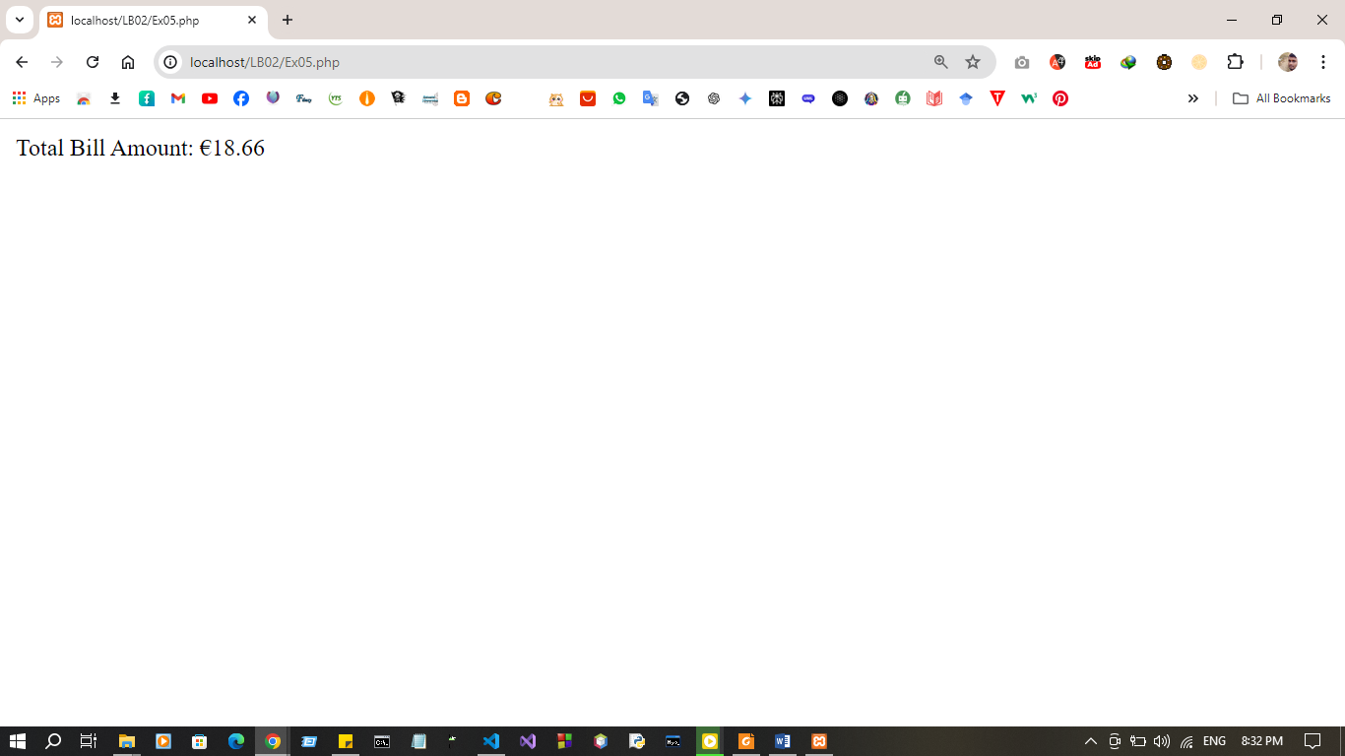

Discussion:
- In this lab session, the objective is to refresh key concepts in PHP, including operators, conditional statements, loops, and to introduce PHP functions and arrays. We start by revisiting the different types of operators in PHP, such as arithmetic, comparison, and logical operators, which are essential for performing various operations within the code. Next, we review PHP conditional statements like if, else, and switch, which help control the flow of the program based on conditions. We then move on to PHP loops (for, while, foreach) to understand how to efficiently handle repetitive tasks. The session also covers PHP functions, which allow us to structure reusable blocks of code, and arrays, which are used to store multiple values in a single variable. These topics lay the foundation for writing more advanced and dynamic PHP applications

